SE 491 BIWEEKLY REPORT 6
sdmay20-25: Consumer Aware Warehouse Management
4/1/20 – 4/15/20
Team Member | Roles
Jimmy Paul  jpaul@craftydelivers.com | Client
Goce Trajcevski  gocet25@iastate.edu | Advisor
Lindsey Sleeth  lssleeth@iastate.edu | Meeting Scribe  Project Manager  Software Developer
Sam Stifter  stifter@iastate.edu | Test Engineer  Software Architect  Software Developer
Omair Ijaz  oijaz@iastate.edu | Quality Assurance Engineer  Meeting Facilitator  Software Developer
Jameel Kelley  jamkelley22@gmail.com | Report Manager  Software Architect  Software Developer
Andrew Smith  arsmith3@iastate.edu | Database Administrator  Quality Assurance Engineer  Software Developer
Elijah Buscho  elijah@iastate.edu | Test Engineer  Software Dev  Proj Manager
Devin Üner  druner@iastate.edu | Software Architect  Machine Learning Specialist

Bi-Weekly Summary

Objective
The objective for this iteration was to finalize any project details and make sure everything is fully integrated and working correctly.

Accomplishments
The frontend is integrated with the backend to provide complete functionality. This includes displaying all distributions and their info, filtering those distributors, searching for those distributors, viewing products in a distributor, viewing the order history of a product, and viewing the missed orders of a product. Only performance related integration such as results paging is left to be integrated.
The machine learning portion has been extended to train on all SKUs, and prediction data is being forwarded to the database.
The backend added some new features in this couple of weeks. One of which was adding an endpoint to only send distributors that have products to reduce irrelevant data being sent and handled. More filters were added in general to allow the frontend to request only the data they needed. { Omair insert accomplishments here}

Summary of Weekly Advisor Meeting
During this week’s advisor meeting we were advised to continue wrapping up final project details and to get started on the final project and poster. We have a meeting scheduled to present to our client the final details of the project and also present to our advisor before our scheduled presentation time.

Past Accomplishments (Individual)
Lindsey Sleeth
This past week I worked with Jameel on integrating and finalizing changes from the backend into the frontend. The previous week we had integrated, but quickly realized there were some edits that needed to be made for performance and to make the data display better. These changes were related to filtering and how much information we were displaying compared to how much information we needed to be displaying. We communicated with the backend team and had them update some endpoints and create some new ones so that we could easily have pagination and filter out distributors with no products to show or be reordered on the frontend. Jameel has included photos of the filters below.

Elijah Buscho
I ran into issues implementing the testing algorithm, because of lack of data and focus being shifted towards tying up loose ends of the project, so I instead generated a graph to show the accuracy of predictions on a single SKU (Passionfruit).

Jameel Kelley
During the past period, attention was focused on integrating the changes on the backend with the frontend to display all the work the team has done thus far and prepare for a demonstration. Individual integration, as well as integration work with Lindsey, has consisted of adding filters, order history graphs, missed orders, and updating API requests. Doing these has placed the fronted into a more finalized state with very few changes left.
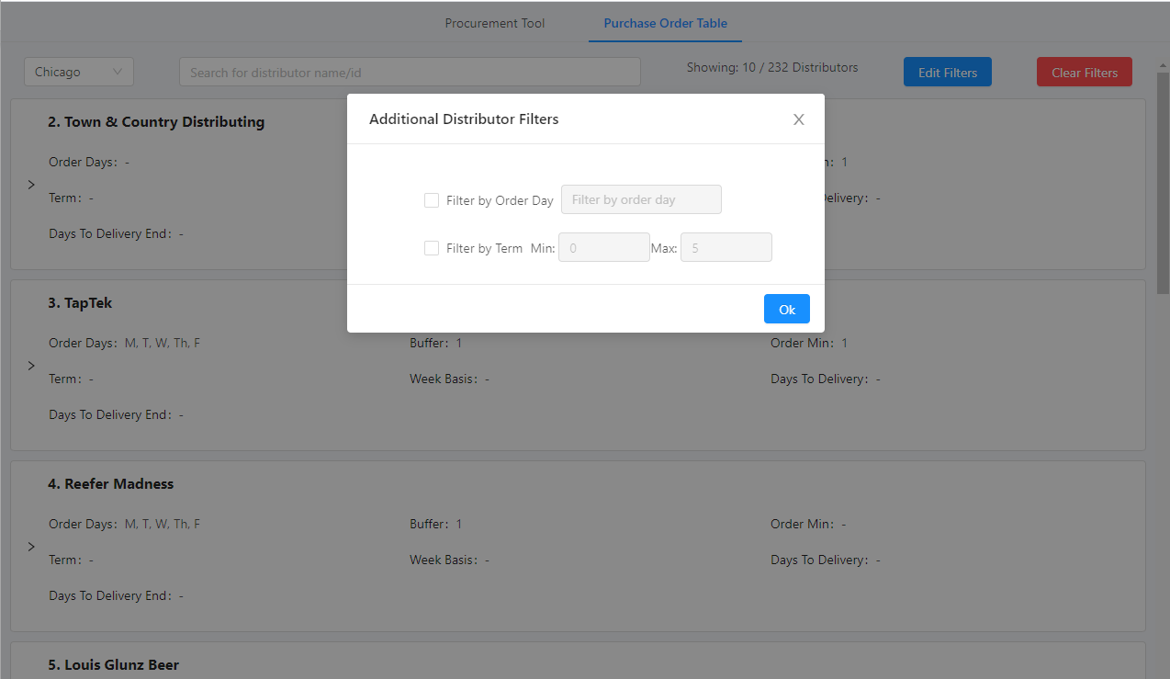
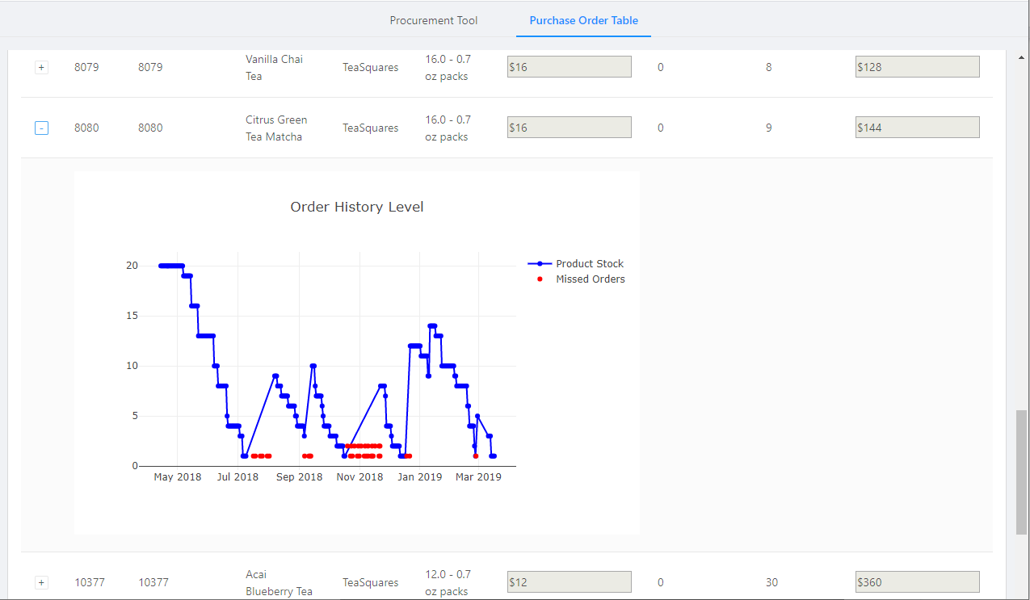

Andrew Smith
Over the past two weeks I worked on the design document and added comments for the area that need to be revised. I also worked on making a new endpoint for the frontend for getting only distributors with products so we aren’t sending distributors who we won’t be placing orders with because they don’t have products. I also added the flag to not send distributors that have the attribute deleted equal to true. I think this flag is there in the database so if that distributor ever distributes with Crafty again it will be easier to on board them again.

Omair Ijaz
With the project winding down, I decided to wrap any missing details. With Sam, I worked on paginating some endpoints for the frontend. This helped the frontend better display results of queries. Throughout the week, I got more requests to paginate certain endpoints. In addition, I have also began to look over the design doc and presentation from last semester to begin revision on the parts that I wrote.

Sam Stifter
This week I started working on revision of the design document. I also finished up the endpoints we needed by creating some filters so the frontend would not have to do filtering manually. I also worked with Omair to create pagination in the endpoint results so the data came back in a more manageable form.

Devin Üner
I worked on making a script to get all the SKUs so we could train on all of them. I also found a small bug in the ML algorithm that should potentially increase its accuracy. I also worked on fully integrating the algorithm with the backend architecture, so it can push and pull predictions. Also worked with Lindsey to get the umlaut on my last name on the poster.

Individual Contributions
Name | Individual Contributions | Hours this Period | Hours Cumulative
Lindsey Sleeth | Frontend Integration, Final Presentation and Poster | 12 | 47
Jameel Kelley | Frontend Integration (adding filters, order history graphs, missed orders, and updating API requests) | 18 | 57
Sam Stifter | Document revisions, pagination for endpoints, filtered endpoints | 10 | 72
Andrew Smith | Design Document edits and new endpoint for only distributors with products | 12 | 76
Omair Ijaz | Pagination | 11 | 65
Elijah Buscho | Accuracy visual | 10 | 61
Devin Üner | Bug fixes, integration with ML algo and backend | 15

Pending Issues
Lindsey Sleeth
There are currently no pending issues.

Elijah Buscho
N/A

Jameel Kelley
No pending issues. Continued testing of individual distributors to see if any issues present themselves

Andrew Smith
No pending issues

Omair Ijaz
No pending issues, unless frontend requires an endpoint

Sam Stifter
Waiting on Frontend to report any issues for bug fixes if any are found.

Devin Üner
none

Upcoming Plans
Lindsey Sleeth
I will be finishing the poster and presentation for the presentation.

Elijah Buscho
Revising report and rehearsing presentation. Adding to testing section of report.

Jameel Kelley
Once the pagination of distributor endpoints is integrated into master, integration into the frontend will be worked on as time permits. Working on the presentation for Monday is also a priority.

Andrew Smith
Upcoming I plan on working on the presentation and finishing up the design document and other reports we need to finish.

Omair Ijaz
From here on out, I will be working on the poster/presentation/design doc and helping develop any new backend queries that are required.

Sam Stifter
Revising the design document fully, writing documentation for the final report. I will also be working on the presentation slides.

Devin Üner
Double check the validity of some integration code I wrote to get all the SKUs.

